HEALTHCARE APPOINTMENT MANAGEMENT PLATFORM DOCUMENTATION

TRELLO BOARD :
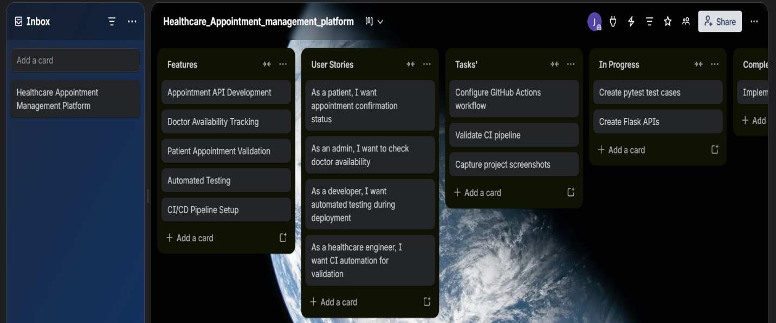

GITHUB REPOSITORY :
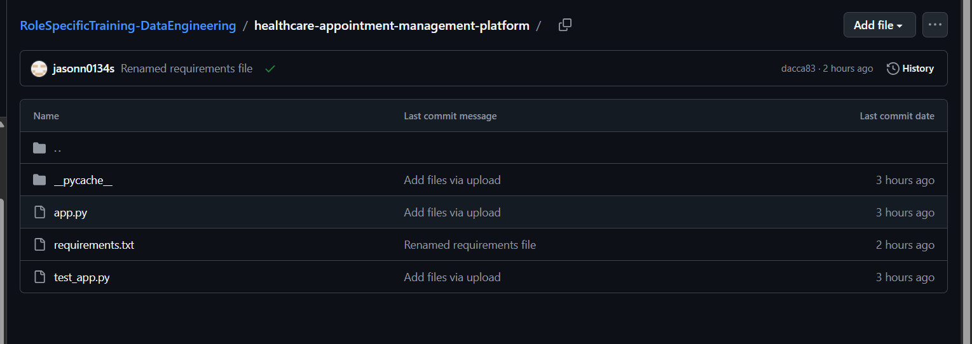

GITHUB PIPELINE CREATION :

